**My First Android App**

Now if you are here to get help in building your own Android App so I expect you would be already knowing about either **Java/Kotlin** and **XML** and you would have already installed **Android Studio** on your Work Station if not and you need help doing that then you can refer to “[A Getting Start Roadmap for Aspiring Android Developers-2021 - LetsCodee](https://letscodee.com/2021/05/21/a-getting-start-roadmap-for-an-aspiring-android-developer-in-2021/)” and get back here to continue with the Android App.

**So, Lets Codee**

As we start **Android Studio,** we see this window

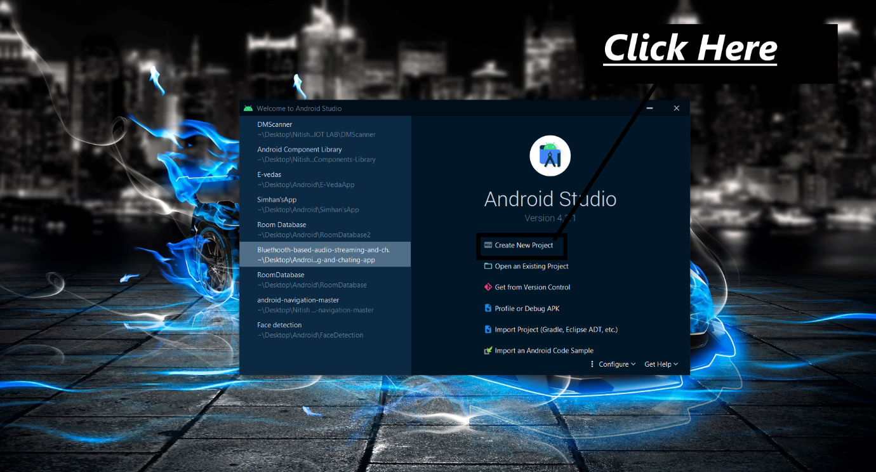

**Creating New Project:**

Click on **“Empty Activity”** and the on **“Next”** Button.

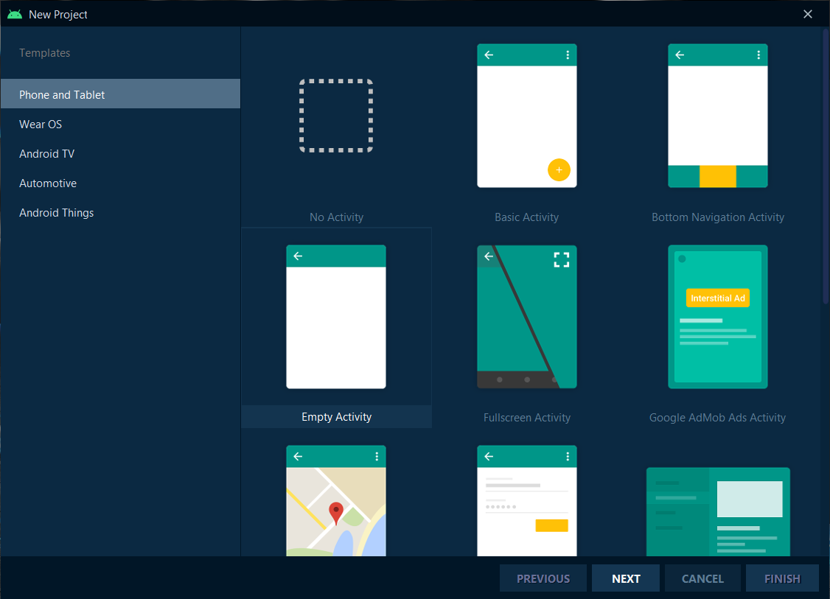

**Project Setup:**

Enter the Project Name, Package Name, Project Storage Location, Language you want to code in and the Minimum Sdk (should be low so that it can run on all the Android devices may it be old), now click on “Finish”.

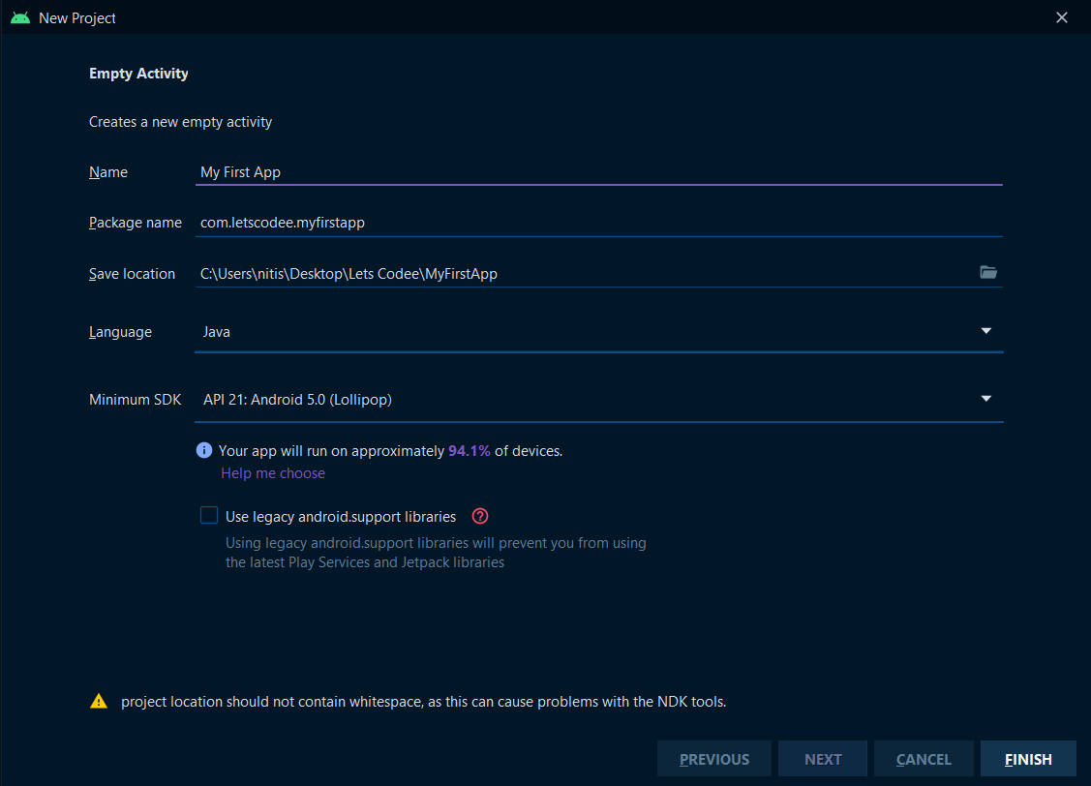

Now let the project build up

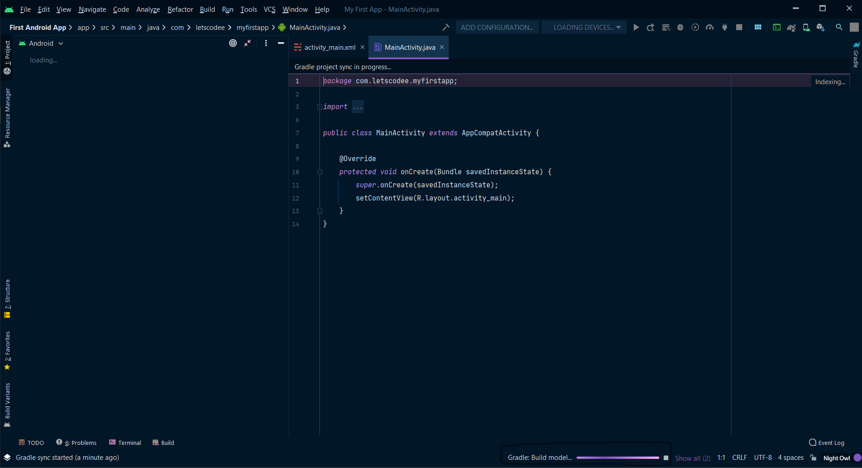

Let the bar in the bottom disappear completely then your project gets build up completely.

After the complete build you can see these file in Android Studio so the main file that we need to work with are “com.letscodee.myfirstapp” and “layout”.

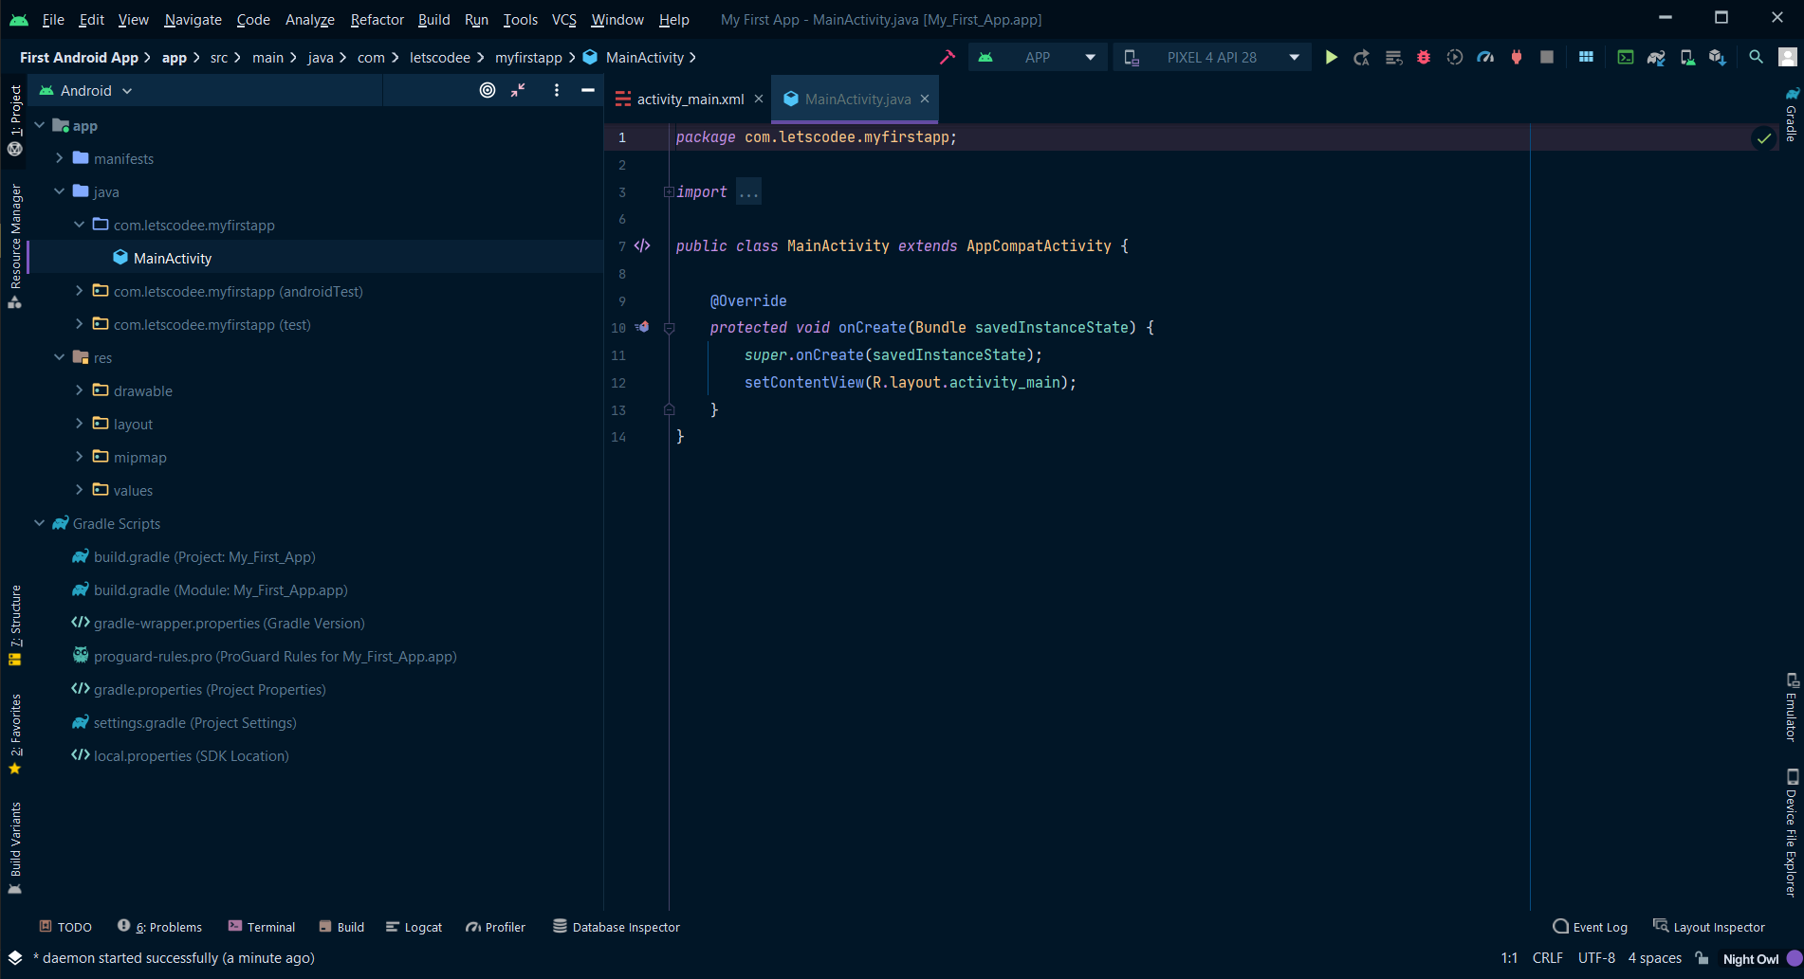

**Editing the User Interface:**

Now open the Layout Folder and then the **“activity_main.xml”** file then select the split mode on the top right to see the code and the design on the same time. Then write the code bellow.

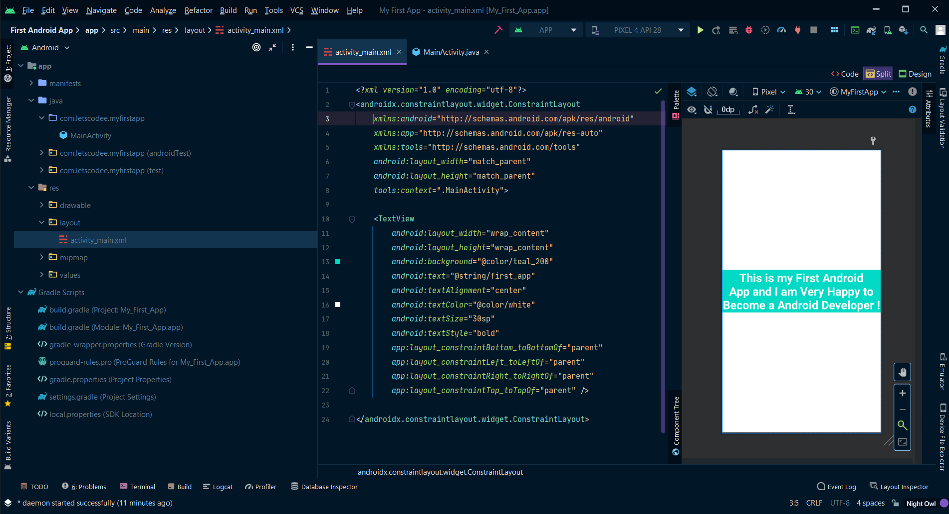

<?xml version="1.0" encoding="utf-8"?>

<androidx.constraintlayout.widget.ConstraintLayout

xmlns:android="http://schemas.android.com/apk/res/android"

xmlns:app="http://schemas.android.com/apk/res-auto"

xmlns:tools="http://schemas.android.com/tools"

android:layout_width="match_parent"

android:layout_height="match_parent"

tools:context=".MainActivity">

<TextView

android:layout_width="wrap_content"

android:layout_height="wrap_content"

android:background="@color/teal_200"

android:text="@string/first_app"

android:textAlignment="center"

android:textColor="@color/white"

android:textSize="30sp"

android:textStyle="bold"

app:layout_constraintBottom_toBottomOf="parent"

app:layout_constraintLeft_toLeftOf="parent"

app:layout_constraintRight_toRightOf="parent"

app:layout_constraintTop_toTopOf="parent" />

<TextView

android:layout_width="wrap_content"

android:layout_height="wrap_content"

android:layout_marginEnd="48dp"

android:layout_marginBottom="36dp"

android:text="LetsCodee.com"

android:background="@color/teal_200"

android:textAlignment="center"

android:textColor="@color/white"

android:textSize="30sp"

android:textStyle="bold"

app:layout_constraintBottom_toBottomOf="parent"

app:layout_constraintEnd_toEndOf="parent" />

</androidx.constraintlayout.widget.ConstraintLayout>

**MainActivity.Java**

package com.letscodee.myfirstapp;

import androidx.appcompat.app.AppCompatActivity;

import android.os.Bundle;

public class MainActivity extends AppCompatActivity {

@Override

protected void onCreate(Bundle savedInstanceState) {

super.onCreate(savedInstanceState);

setContentView(R.layout.activity_main);

}

}

**AndroidManifest.xml**

<?xml version="1.0" encoding="utf-8"?>

<manifest xmlns:android="http://schemas.android.com/apk/res/android"

package="com.letscodee.myfirstapp">

<application

android:allowBackup="true"

android:icon="@mipmap/ic_launcher"

android:label="@string/app_name"

android:roundIcon="@mipmap/ic_launcher_round"

android:supportsRtl="true"

android:theme="@style/Theme.MyFirstApp">

<activity

android:name=".MainActivity">

<intent-filter>

<action android:name="android.intent.action.MAIN" />

<category android:name="android.intent.category.LAUNCHER" />

</intent-filter>

</activity>

</application>

</manifest>

**First Android App\app\src\main\res\values\string.xml**

<resources>

<string name="app_name">My First App</string>

<string name="first_app">This is my First Android App and I am Very Happy to Become a Android Developer !</string>

</resources>

**First Android App\app\build.gradel**

plugins {

id 'com.android.application'

}

android {

compileSdkVersion 30

buildToolsVersion "30.0.3"

defaultConfig {

applicationId "com.letscodee.myfirstapp"

minSdkVersion 21

targetSdkVersion 30

versionCode 1

versionName "1.0"

testInstrumentationRunner "androidx.test.runner.AndroidJUnitRunner"

}

buildTypes {

release {

minifyEnabled false

proguardFiles getDefaultProguardFile('proguard-android-optimize.txt'), 'proguard-rules.pro'

}

}

compileOptions {

sourceCompatibility JavaVersion.VERSION_1_8

targetCompatibility JavaVersion.VERSION_1_8

}

}

dependencies {

implementation 'androidx.appcompat:appcompat:1.3.0'

implementation 'com.google.android.material:material:1.3.0'

implementation 'androidx.constraintlayout:constraintlayout:2.0.4'

testImplementation 'junit:junit:4.+'

androidTestImplementation 'androidx.test.ext:junit:1.1.2'

androidTestImplementation 'androidx.test.espresso:espresso-core:3.3.0'

}

**Let’s Run The App:**

To run the app you either need to have a Android Device connect to Desktop or make a Emulator in “Android Studio” then press the **“Run”** button on top bar shortcut key.

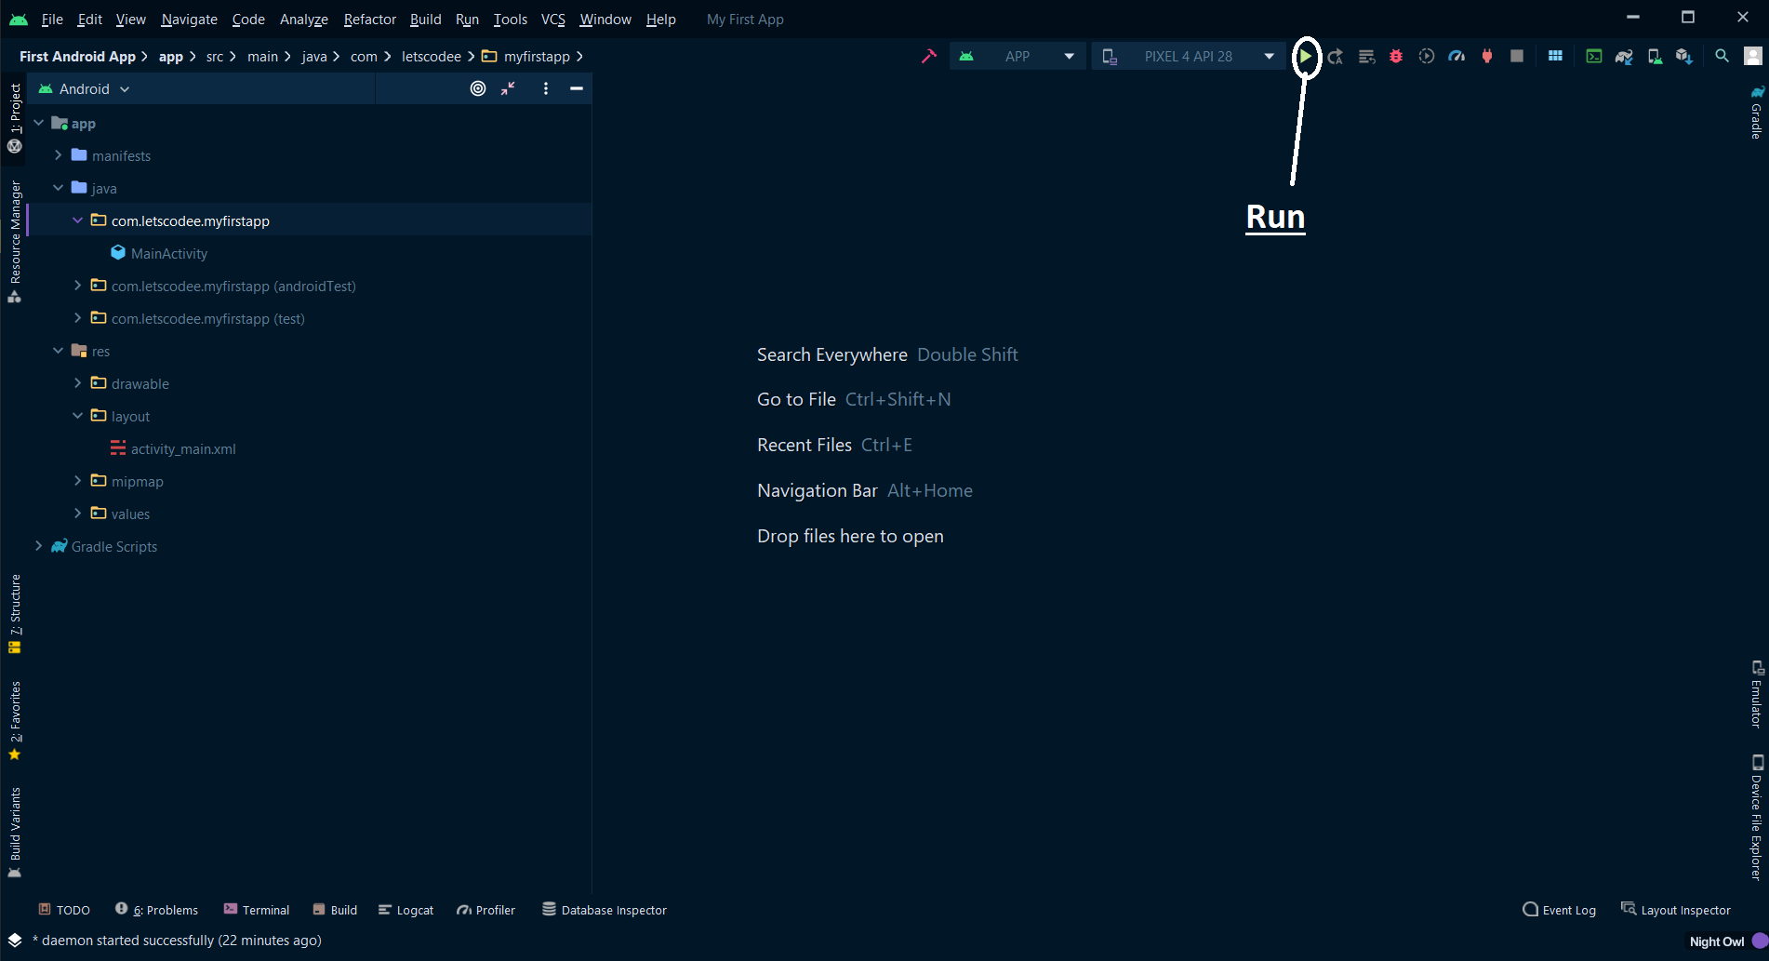

Again, after the complete app gets build the app will start on your device and will look like this.

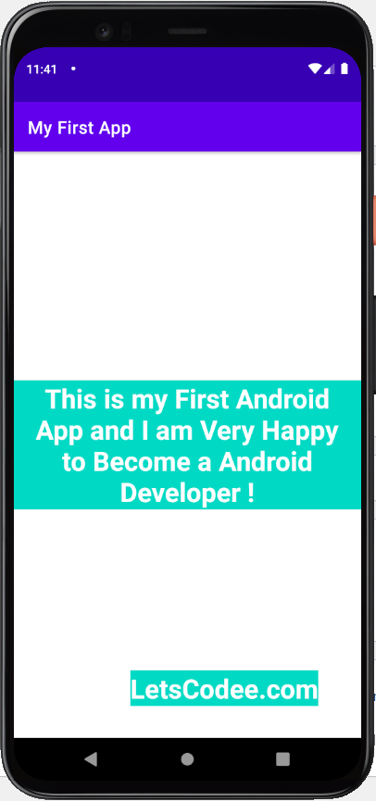

So, this way you build your very own Android App

**Congratulation**

**Keep Coding and building nice project.**

**Thank You ❤**

***Thanks for visiting our website. Our aim is to provide you deeper knowledge about Android, Web and Data science. You can free to contact us for any queries.***